**LAB-1**

**NAME: Ganesh Rajulapati**

**Net ID : dg6865**

**Data base connectivity with python**

**AIM : our aim is to log in into website and upload csv file and do some operations on that file like delete, update, insert. For this we will connect python with database(mysql) and for the website we will create some webpages using Vscode according to the requirement. Finally, need to install some scanning tool to find the vulnerabilities.**

1. **First need to download the mysql server using the link below then configure it correctly.** [**https://dev.mysql.com/downloads/installer/**](https://dev.mysql.com/downloads/installer/)
2. **Download visual studio** [**https://code.visualstudio.com/download**](https://code.visualstudio.com/download) **, select windows**
3. **Download python** [**https://www.python.org/downloads/**](https://www.python.org/downloads/)
4. **Now create two files named as templates and static in visual studio code**
5. **Create python file named as app.y , I will attach the files seperatly**
6. **Now create a required html files for the web app. Once created upload all the html files into the templates folder in the visual studio. I will attach the files seperatly**
7. **Now open the database create database called ‘beginning’**
8. **Create table table name called “persons_data” and add columns such as MemberID, Name, City,ZipCode. Here MemberID is the primary key**

**Note : remember to save the names as usual what I mentioned above otherwise it would lead to error.**

1. **Install mysql alchemy using this commands in your command prompt:**

**C:\Users\STSC>pip install sqlalchemy**

1. **Install pandas using this command :**

**C:\Users\STSC>pip install pandas**

1. **Connecting to mysql ;**

conn = mysql.connector.connect(host='localhost', password='root', user = 'root',database='begining')

1. **Once upload all the files into visual studio your environment look like this :**

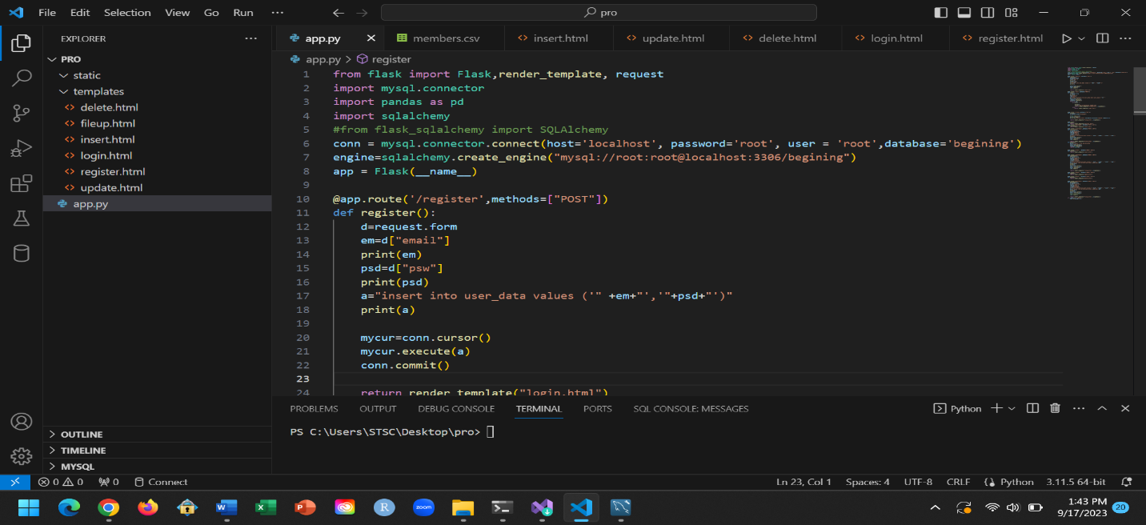

1. **Now run the app.py file on the visual studio, once you run it successfully we will see the link in terminal :** [**http://127.0.0.1:5000**](http://127.0.0.1:5000)
2. **Open the link to access your website**

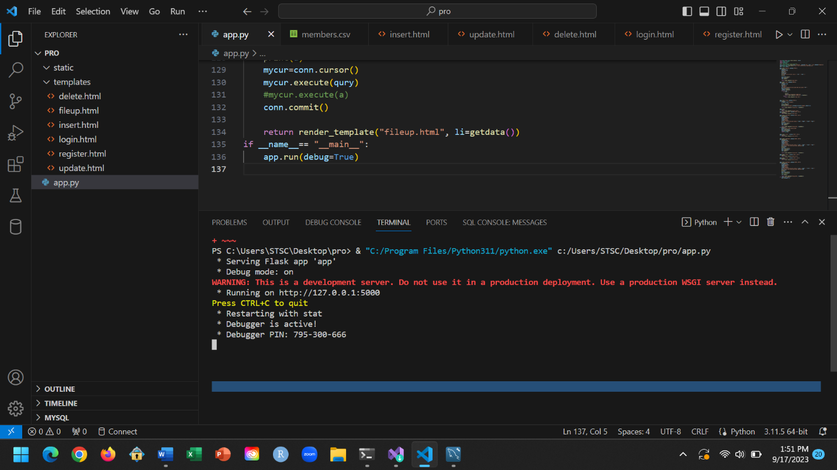

1. **Once you open the link you will see the website and you need to register into the account if you don’t have account in it.**

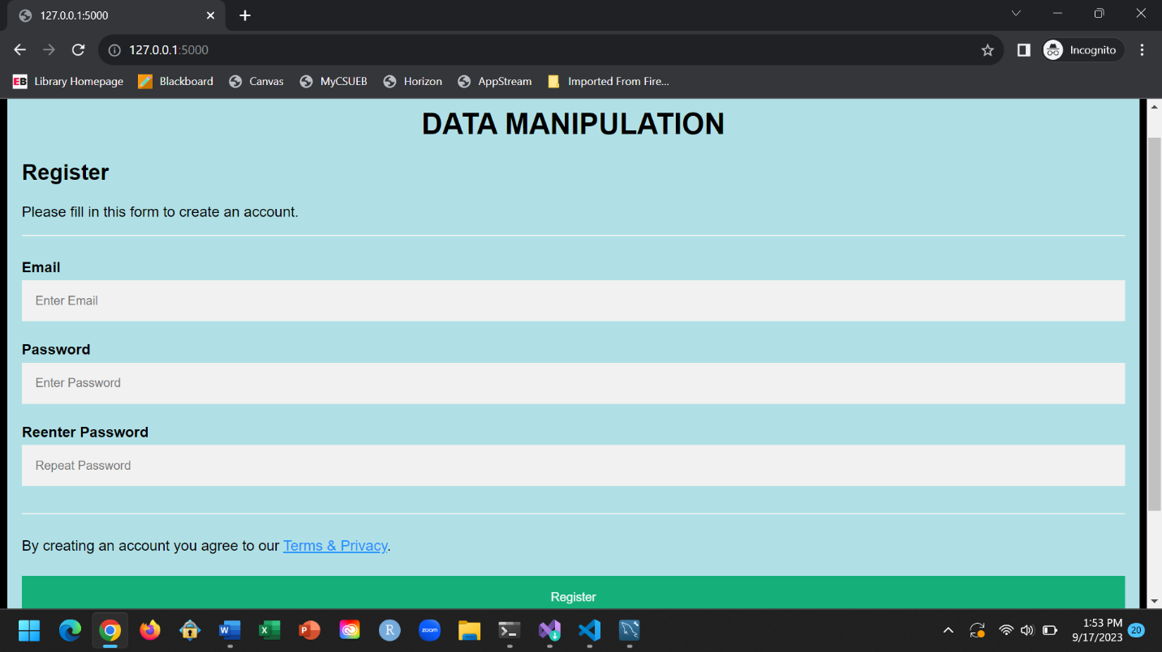

**REGISTRATION PAGE**

1. **Once register you will redirected into the login page, login with your password, if it incorrect you will stay on the login page itself.**

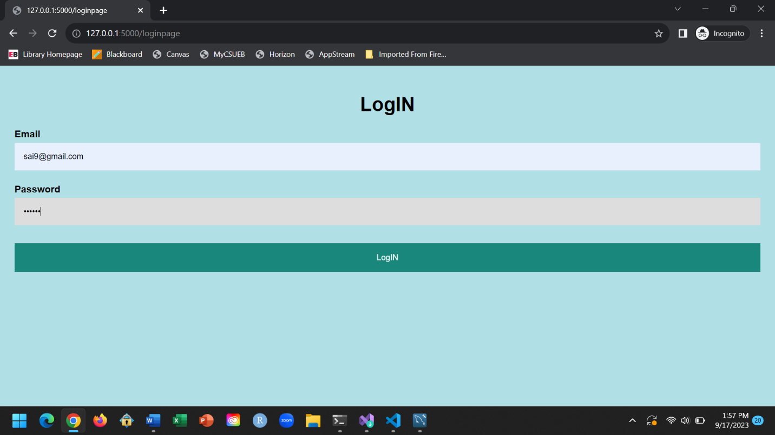

**LOGIN PAGE**

1. **Once you logged in you will be able to upload the files and allowed to data manipulations**

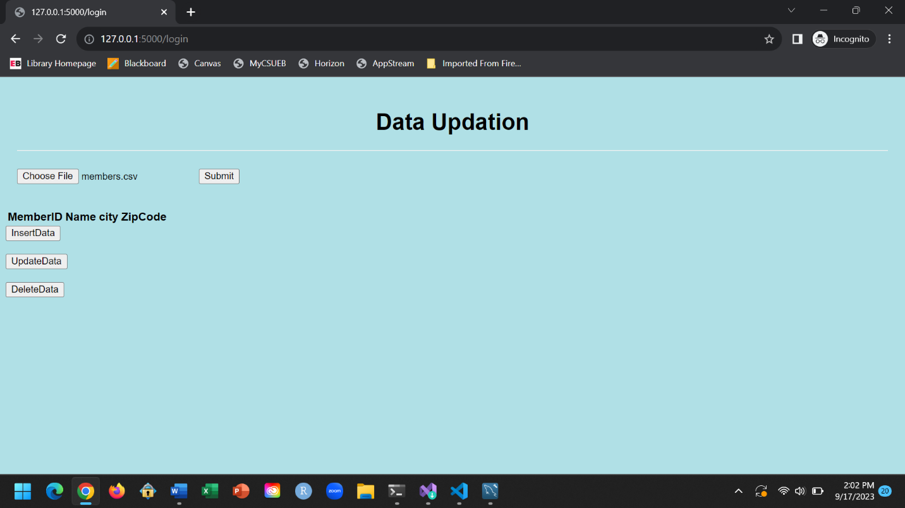

**FILE AND DATA MANIPULATION PAGE**

1. **Once you upload your file you will see the data below**

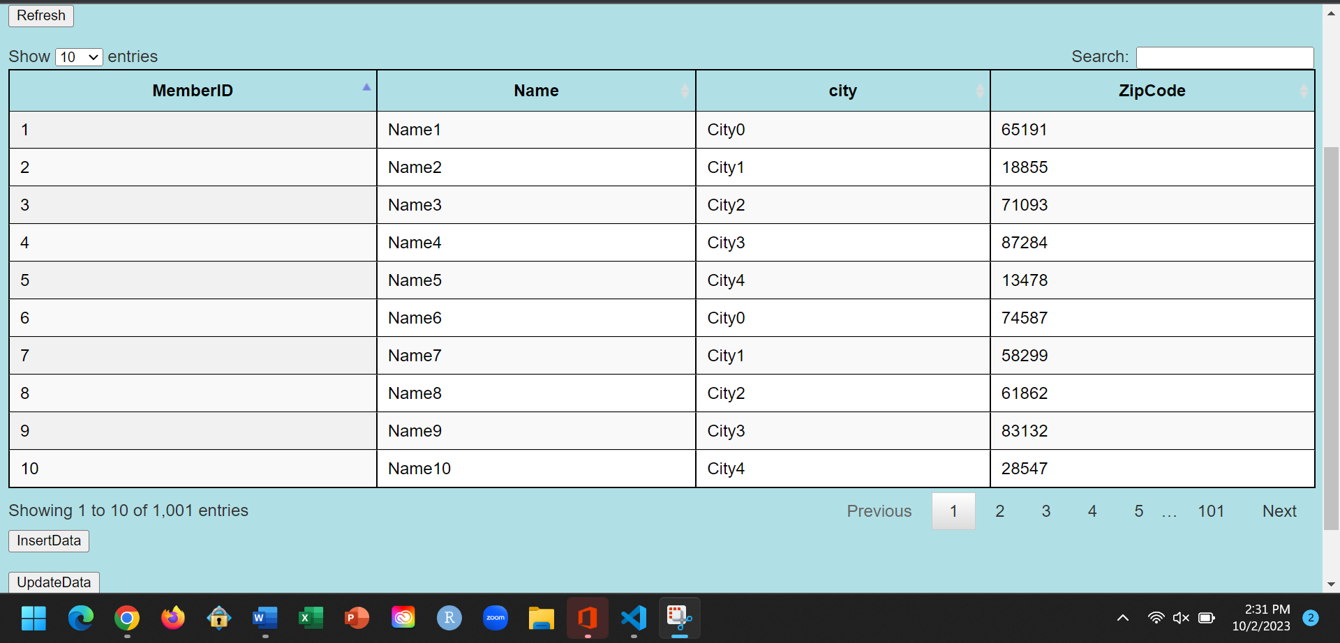

**DSIPLAYING THE FILE CONTENTS**

1. **Now you can insert the data by clicking on insert button below.**

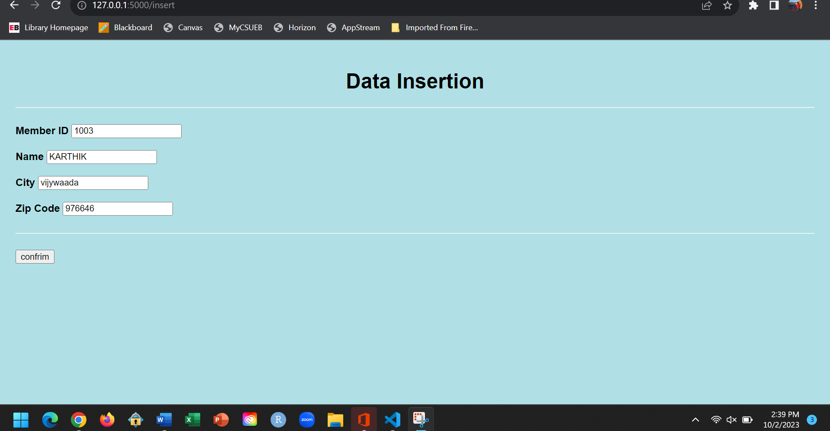

**DATA INSERTION**

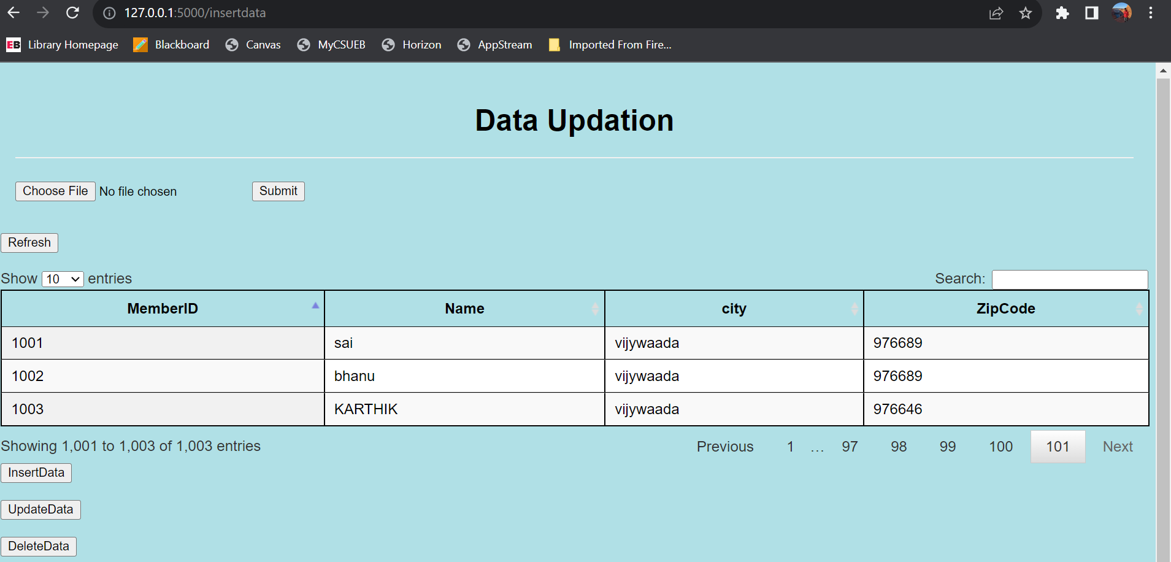

**DISPLAYING THE INSERTED DATA**

1. **Once you click submit you will redirect into the fileup.html and you will the result but here I used slicing to print the first ten rows of the file only so we can slice it to get the last element.**
2. **You delete it the first elements well by clicking on delete**

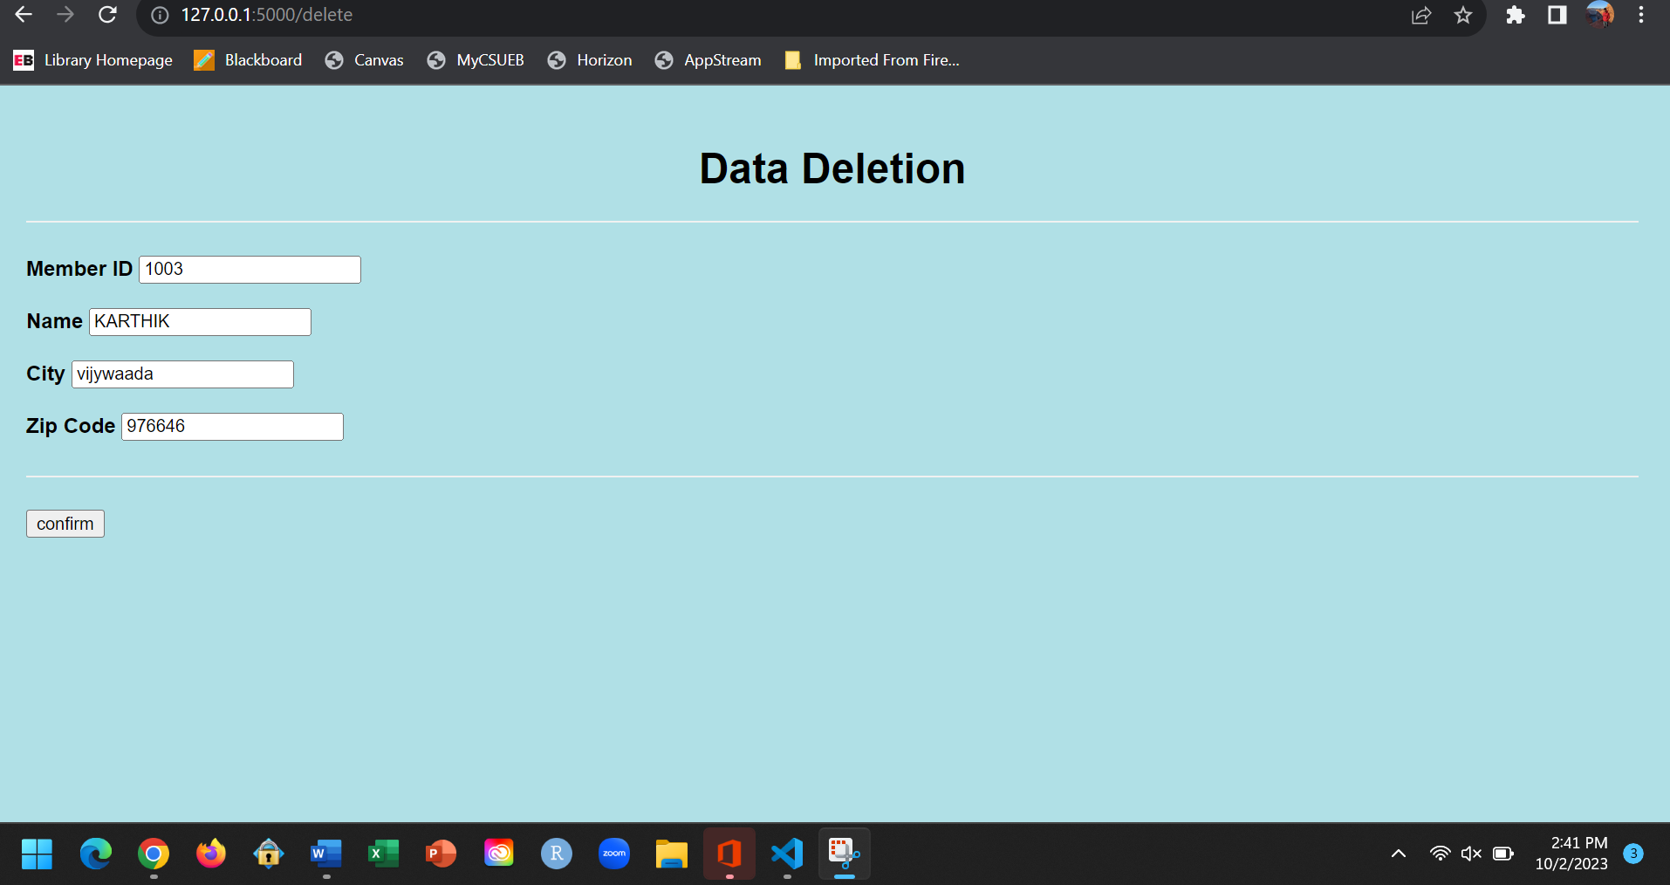

**DELETING THE RECORD**

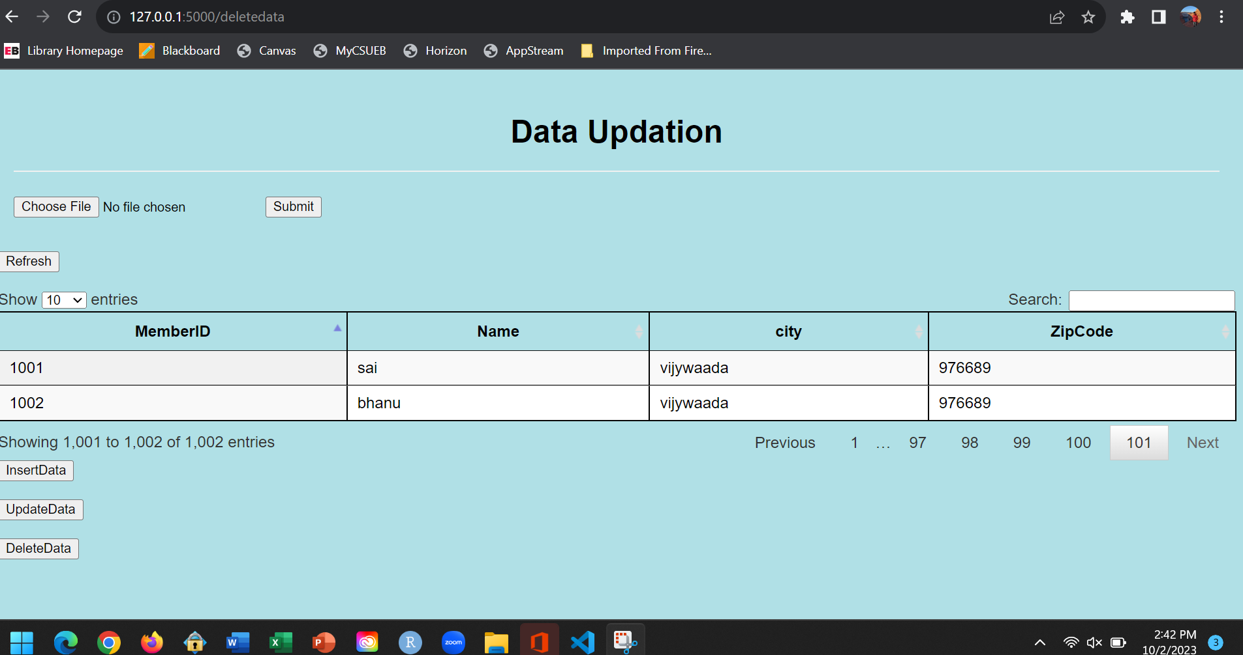

**DISPLAYING THE FILE AFTER DELETING THE RECORD “ID=1003”**

1. **You update the data as well by clicking on update button:**

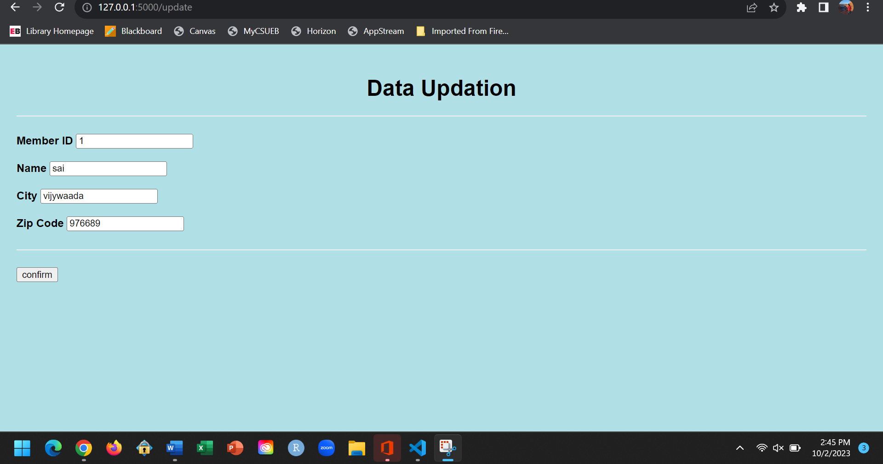

**UPDATING THE RECORD**

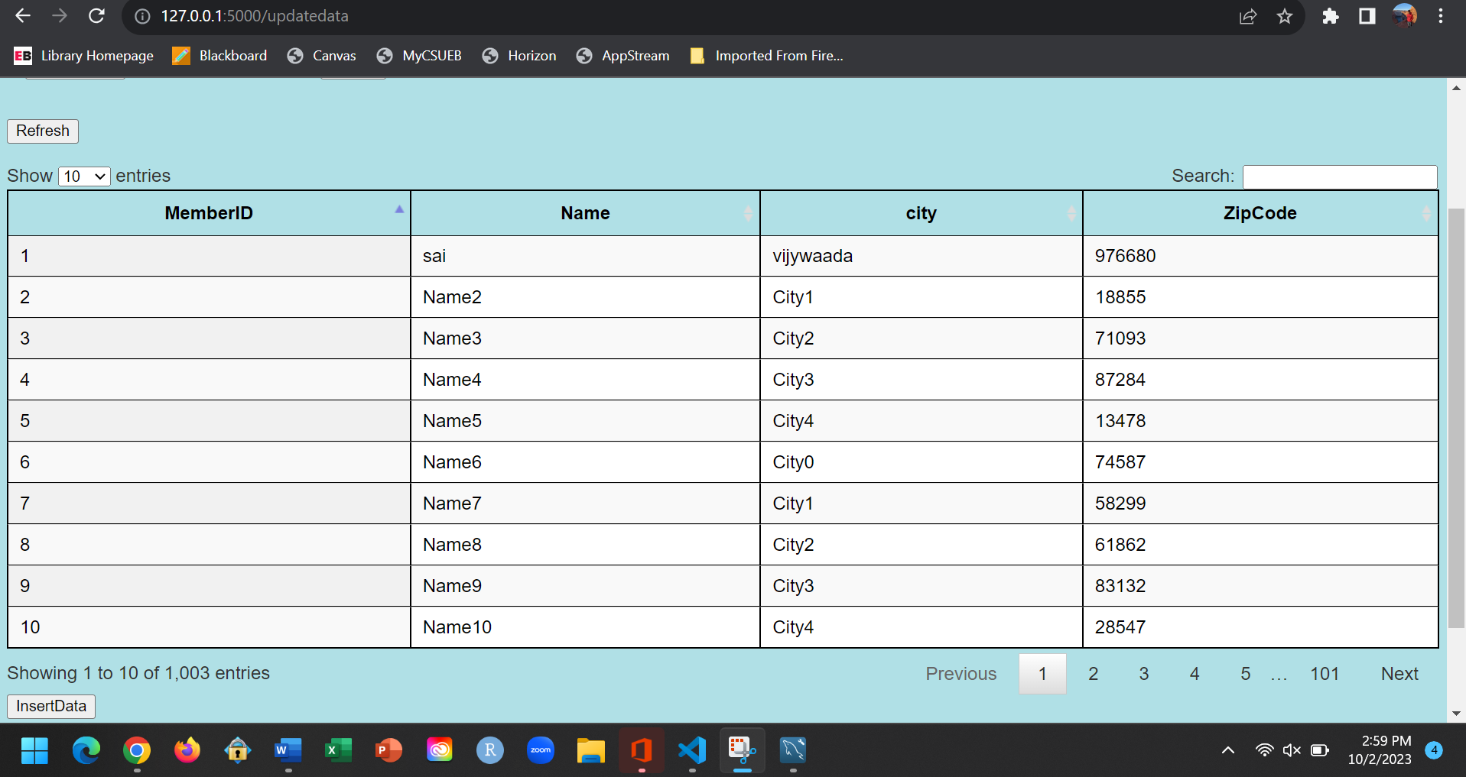

**DISPLAYING THE UPDATED RECORD**

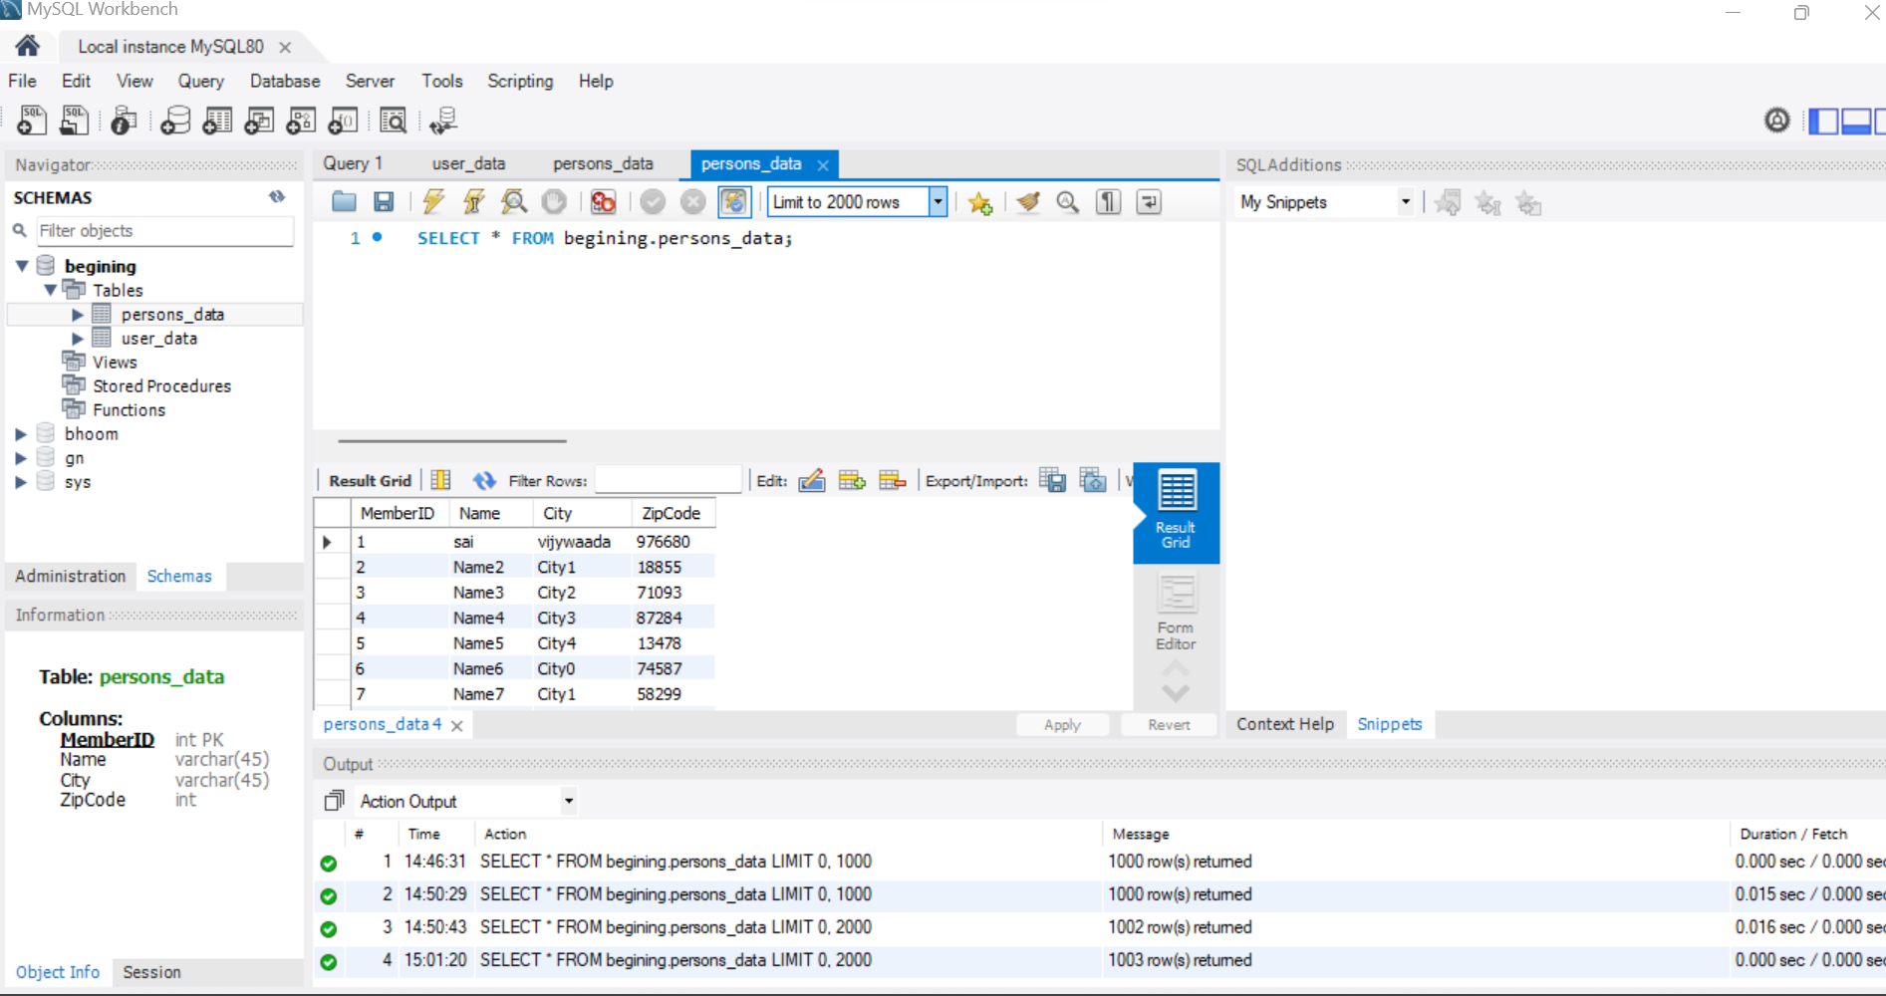

**DISPLAYING THE DATA THROUGH MYSQL WOEKBENCH**

**Result :**

**Creating a website using visual studio and connecting to mysql using python is successfully completed.**